**Practical-18**

**Q18.**  **Java Andorid Program to Perform all arithmetic Operations using Calculators**

**Ans:-**

**Activity_main.xml**

<?xml version="1.0" encoding="utf-8"?>  
<LinearLayout xmlns:android="http://schemas.android.com/apk/res/android"  
 xmlns:app="http://schemas.android.com/apk/res-auto"  
 xmlns:tools="http://schemas.android.com/tools"  
 android:layout_width="match_parent"  
 android:layout_height="match_parent"  
 tools:context=".MainActivity"  
 android:padding="20dp"  
 android:orientation="vertical">  
  
  
 <TextView  
 android:layout_width="wrap_content"  
 android:layout_height="wrap_content"  
 android:text="arithmetic Operations"  
 android:textSize="25sp"  
 android:layout_marginBottom="16dp"  
 android:textColor="@android:color/black" />  
  
 <LinearLayout  
 android:layout_width="match_parent"  
 android:layout_height="wrap_content"  
 android:orientation="horizontal"  
 android:layout_marginBottom="20dp">  
  
 <EditText  
 android:id="@+id/first_no"  
 android:layout_width="102dp"  
 android:layout_height="59dp"  
 android:ems="10"  
 android:layout_marginHorizontal="50dp"  
 android:hint="Enter" />  
  
 <EditText  
 android:id="@+id/second_no"  
 android:layout_width="102dp"  
 android:layout_height="59dp"  
 android:ems="10"  
 android:hint="Enter" />  
  
 </LinearLayout>  
  
 <LinearLayout  
 android:layout_width="wrap_content"  
 android:layout_height="wrap_content"  
 android:orientation="horizontal"  
 android:layout_marginBottom="20dp">  
  
 <TextView  
 android:textSize="35sp"  
 android:id="@+id/answer"  
 android:layout_width="102dp"  
 android:layout_height="59dp"  
 android:layout_marginHorizontal="50dp"  
 android:hint="ans" />  
  
 </LinearLayout>  
  
 <LinearLayout  
 android:orientation="vertical"  
 android:layout_marginLeft="250dp"  
 android:layout_width="wrap_content"  
 android:layout_height="wrap_content"  
 android:layout_marginBottom="30dp">  
  
 <Button  
 android:id="@+id/sub"  
 android:layout_width="wrap_content"  
 android:layout_height="wrap_content"  
 android:text="sub -"  
 android:textSize="25sp"  
 android:layout_marginBottom="16dp" />  
  
 <Button  
 android:id="@+id/add"  
 android:layout_width="wrap_content"  
 android:layout_height="wrap_content"  
 android:layout_marginBottom="16dp"  
 android:text="add +"  
 android:textSize="25sp"  
 tools:ignore="OnClick" />  
  
 <Button  
 android:id="@+id/div"  
 android:layout_width="wrap_content"  
 android:layout_height="wrap_content"  
 android:text="divide /"  
 android:textSize="25sp"  
 android:layout_marginBottom="16dp" />  
  
 <Button  
 android:id="@+id/mul"  
 android:layout_width="wrap_content"  
 android:layout_height="wrap_content"  
 android:layout_marginBottom="16dp"  
 android:text="mul X"  
 android:textSize="25sp"/>  
  
 <Button  
 android:id="@+id/equals"  
 android:layout_width="wrap_content"  
 android:layout_height="wrap_content"  
 android:layout_marginBottom="16dp"  
 android:text="="  
 android:textSize="35sp"/>  
 </LinearLayout>  
  
  
</LinearLayout>

**MainActivity.java**

package com.example.pratical18;  
  
//import androidx.appcompat.app.AppCompatActivity;  
  
import android.os.Bundle;  
import android.support.v7.app.AppCompatActivity;  
import android.view.View;  
import android.widget.Button;  
import android.widget.EditText;  
import android.widget.TextView;  
import android.widget.Toast;  
  
public class MainActivity extends AppCompatActivity {  
  
 EditText no1 , no2;  
 Button add ,mul ,div , sub,equal;  
 TextView answer;  
 double ans = 0;  
  
 @Override  
 protected void onCreate(Bundle savedInstanceState) {  
 super.onCreate(savedInstanceState);  
 setContentView(R.layout.*activity_main*);  
  
  
  
 // for text views  
 no1 = findViewById(R.id.*first_no*);  
 no2 = findViewById(R.id.*second_no*);  
  
 // for button with operations  
 add = findViewById(R.id.*add*);  
 mul = findViewById(R.id.*mul*);  
 div = findViewById(R.id.*div*);  
 sub = findViewById(R.id.*sub*);  
  
 // for equal to button  
 equal = findViewById(R.id.*equals*);  
  
 // for answer field  
 answer = findViewById(R.id.*answer*);  
  
 add.setOnClickListener(new View.OnClickListener() {  
 @Override  
 public void onClick(View v) {  
 String num1 = no1.getText().toString();  
 String num2 = no2.getText().toString();  
  
 if (num1.isEmpty() || num2.isEmpty()) {  
 Toast.*makeText*(getApplicationContext(),"Enter Numbers",Toast.*LENGTH_SHORT*).show();  
 }  
 else {  
 double a = Double.*parseDouble*(no1.getText().toString());  
 double b = Double.*parseDouble*(no2.getText().toString());  
 ans = a + b;  
 }  
 }  
 });  
  
 sub.setOnClickListener(new View.OnClickListener() {  
 @Override  
 public void onClick(View v) {  
 String num1 = no1.getText().toString();  
 String num2 = no2.getText().toString();  
  
 if (num1.isEmpty() || num2.isEmpty()) {  
 Toast.*makeText*(getApplicationContext(),"Enter Numbers",Toast.*LENGTH_SHORT*).show();  
 }  
 else {  
 double a = Double.*parseDouble*(no1.getText().toString());  
 double b = Double.*parseDouble*(no2.getText().toString());  
 ans = a - b;  
 }  
 }  
 });  
  
 mul.setOnClickListener(new View.OnClickListener() {  
 @Override  
 public void onClick(View v) {  
 String num1 = no1.getText().toString();  
 String num2 = no2.getText().toString();  
  
 if (num1.isEmpty() || num2.isEmpty()) {  
 Toast.*makeText*(getApplicationContext(),"Enter Numbers",Toast.*LENGTH_SHORT*).show();  
 }  
 else {  
 double a = Double.*parseDouble*(no1.getText().toString());  
 double b = Double.*parseDouble*(no2.getText().toString());  
 ans = a * b;  
 }  
 }  
 });  
  
 div.setOnClickListener(new View.OnClickListener() {  
 @Override  
 public void onClick(View v) {  
 String num1 = no1.getText().toString();  
 String num2 = no2.getText().toString();  
  
 if (num1.isEmpty() || num2.isEmpty()) {  
 Toast.*makeText*(getApplicationContext(), "Enter Numbers", Toast.*LENGTH_SHORT*).show();  
 } else {  
 double a = Double.*parseDouble*(no1.getText().toString());  
 double b = Double.*parseDouble*(no2.getText().toString());  
 if (b != 0)  
 ans = a / b;  
 else  
 Toast.*makeText*(getApplicationContext(), "Enter Valid Numbers", Toast.*LENGTH_SHORT*).show();  
 }  
 }  
 });  
  
 equal.setOnClickListener(new View.OnClickListener() {  
 @Override  
 public void onClick(View v) {  
 String ans1 = String.*valueOf*(ans);  
 answer.setText(ans1);  
 ans= 0;  
 }  
 });  
  
 }  
}

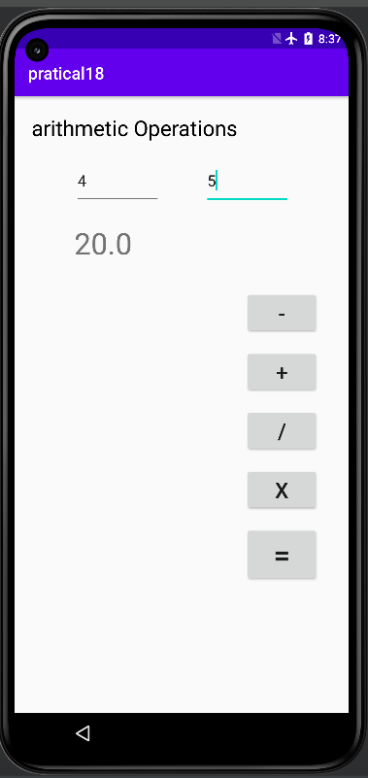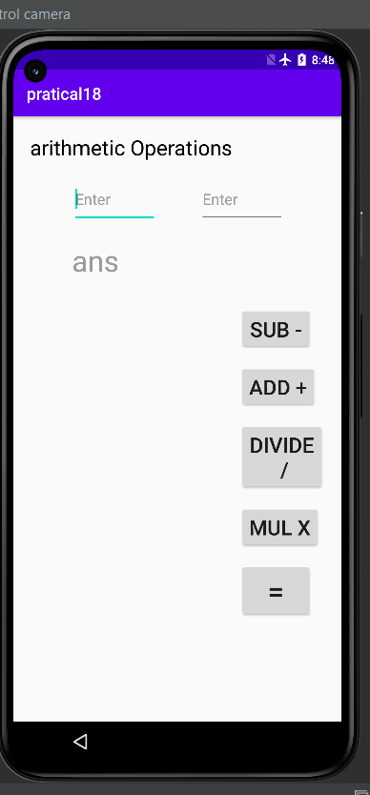**Output:-**

**Practical-19**

**Q19.**  **Java Android Program to Change the Image Displayed on the Screen**

**Ans:-**

**Activity_main.xml**

<?xml version="1.0" encoding="utf-8"?>  
<RelativeLayout xmlns:android="http://schemas.android.com/apk/res/android"  
 xmlns:tools="http://schemas.android.com/tools"  
 android:layout_width="match_parent"  
 android:layout_height="match_parent"  
 tools:context=".MainActivity" >  
  
 <LinearLayout  
 android:layout_width="match_parent"  
 android:layout_height="wrap_content"  
 android:orientation="horizontal"  
 android:paddingBottom="40px"  
 android:weightSum="2" >  
  
 <RadioGroup  
 android:id="@+id/rg1"  
 android:layout_width="wrap_content"  
 android:layout_height="match_parent"  
 android:layout_weight="1"  
 android:orientation="vertical" >  
  
 <RadioButton  
 android:id="@+id/radioButton1"  
 android:layout_width="wrap_content"  
 android:layout_height="wrap_content"  
 android:layout_alignParentRight="true"  
 android:layout_alignParentTop="true"  
 android:layout_marginTop="20dp"  
 android:text="Image2" />  
  
 <RadioButton  
 android:id="@+id/radioButton2"  
 android:layout_width="wrap_content"  
 android:layout_height="wrap_content"  
 android:layout_alignBaseline="@+id/radioButton1"  
 android:layout_alignBottom="@+id/radioButton1"  
 android:layout_alignParentLeft="true"  
 android:text="Image1" />  
 </RadioGroup>  
  
 <RadioGroup  
 android:id="@+id/rg2"  
 android:layout_width="wrap_content"  
 android:layout_height="match_parent"  
 android:layout_weight="1"  
 android:orientation="vertical" >  
  
 <RadioButton  
 android:id="@+id/radioButton3"  
 android:layout_width="wrap_content"  
 android:layout_height="wrap_content"  
 android:layout_marginTop="30dp"  
 android:text="Image3" />  
  
 <RadioButton  
 android:id="@+id/radioButton4"  
 android:layout_width="wrap_content"  
 android:layout_height="wrap_content"  
 android:layout_alignBaseline="@+id/radioButton3"  
 android:layout_alignBottom="@+id/radioButton3"  
 android:layout_alignParentRight="true"  
 android:text="Image4" />  
 </RadioGroup>  
 </LinearLayout>  
  
 <Button  
 android:id="@+id/button1"  
 android:layout_width="wrap_content"  
 android:layout_height="wrap_content"  
 android:layout_alignParentLeft="true"  
 android:layout_alignParentRight="true"  
 android:layout_centerVertical="true"  
 android:text="Change Image" />  
  
 <ImageView  
 android:id="@+id/imageView1"  
 android:layout_width="wrap_content"  
 android:layout_height="wrap_content"  
 android:layout_alignLeft="@+id/button1"  
 android:layout_alignParentBottom="true"  
 android:layout_alignParentRight="true"  
 android:layout_below="@+id/button1"  
 android:layout_marginTop="50dp"/>  
  
</RelativeLayout>

**MainActivity.java**

package com.example.pra18;  
  
  
import android.app.Activity;  
import android.graphics.Typeface;  
import android.os.Bundle;  
import android.renderscript.Type;  
import android.view.Gravity;  
import android.view.View;  
import android.widget.Button;  
import android.widget.EditText;  
import android.widget.ImageView;  
import android.widget.RadioGroup;  
import android.widget.RadioGroup.OnCheckedChangeListener;  
import android.widget.TextView;  
  
public class MainActivity extends Activity implements OnCheckedChangeListener {  
  
 RadioGroup group1, group2;  
 Button gen;  
 ImageView img;  
  
 @Override  
 protected void onCreate(Bundle savedInstanceState) {  
 // *TODO Auto-generated method stub* super.onCreate(savedInstanceState);  
 setContentView(R.layout.*activity_main*);  
  
 group1 = (RadioGroup) findViewById(R.id.*rg1*);  
 group1.setOnCheckedChangeListener((OnCheckedChangeListener) this);  
  
 group2 = (RadioGroup) findViewById(R.id.*rg2*);  
 group2.setOnCheckedChangeListener((OnCheckedChangeListener) this);  
  
 img = (ImageView) findViewById(R.id.*imageView1*);  
 // oncheckedChanged function  
 gen = (Button) findViewById(R.id.*button1*);  
 gen.setOnClickListener(new View.OnClickListener() {  
  
 @Override  
 public void onClick(View v) {  
 // *TODO Auto-generated method stub* }  
 });  
  
 }  
  
 @Override  
 public void onCheckedChanged(RadioGroup group, int checkedId) {  
 // *TODO Auto-generated method stub* switch (checkedId) {  
 case R.id.*radioButton1*:  
 img.setImageResource(R.drawable.*image4*);  
 break;  
  
 case R.id.*radioButton2*:  
 img.setImageResource(R.drawable.*image5*);  
 break;  
  
 case R.id.*radioButton3*:  
 img.setImageResource(R.drawable.*image6*);  
 break;  
  
 case R.id.*radioButton4*:  
 img.setImageResource(R.drawable.*image7*);  
 break;  
  
 default:  
 break;  
 }  
 }  
}

**Output:-**

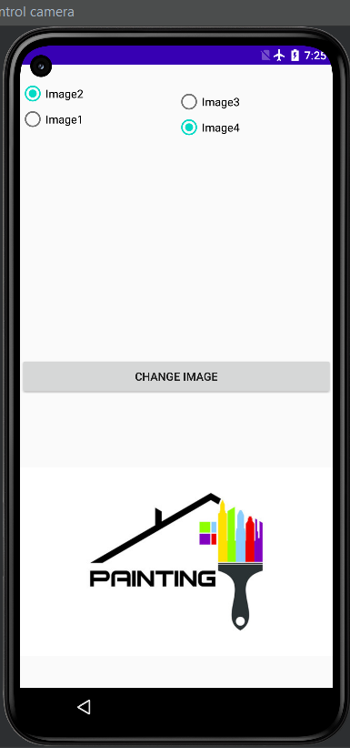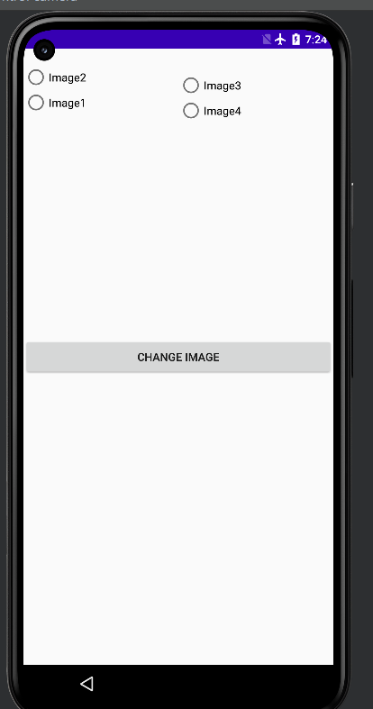

**Practical-20**

**Q20.**  **java android program to demonstrate alert dialog box**

**Ans:-**

**Activity_main.xml**

<?xml version="1.0" encoding="utf-8"?>  
<android.support.constraint.ConstraintLayout xmlns:android="http://schemas.android.com/apk/res/android"  
 xmlns:app="http://schemas.android.com/apk/res-auto"  
 xmlns:tools="http://schemas.android.com/tools"  
 android:layout_width="match_parent"  
 android:layout_height="match_parent"  
 tools:context=".MainActivity">  
  
 <Button  
 android:layout_width="wrap_content"  
 android:layout_height="wrap_content"  
 android:id="@+id/button"  
 android:text="Close app"  
 app:layout_constraintBottom_toBottomOf="parent"  
 app:layout_constraintLeft_toLeftOf="parent"  
 app:layout_constraintRight_toRightOf="parent"  
 app:layout_constraintTop_toTopOf="parent" />  
  
</android.support.constraint.ConstraintLayout>

**Values**

**Strings.xml**

<resources>  
 <string name="app_name">AlertDialog</string>  
 <string name="dialog_message">Welcome to Alert Dialog</string>  
 <string name="dialog_title">Javatpoint Alert Dialog</string>  
</resources>

**MainActivity.java**

package com.example.pratical20;  
  
import android.content.DialogInterface;  
import android.support.v7.app.AppCompatActivity;  
import android.os.Bundle;  
import android.view.View;  
import android.widget.Button;  
import android.app.AlertDialog;  
import android.widget.Toast;  
  
public class MainActivity extends AppCompatActivity {  
 Button closeButton;  
 AlertDialog.Builder builder;  
 @Override  
 protected void onCreate(Bundle savedInstanceState) {  
 super.onCreate(savedInstanceState);  
 setContentView(R.layout.*activity_main*);  
  
 closeButton = (Button) findViewById(R.id.*button*);  
 builder = new AlertDialog.Builder(this);  
 closeButton.setOnClickListener(new View.OnClickListener() {  
 @Override  
 public void onClick(View v) {  
  
 //Uncomment the below code to Set the message and title from the strings.xml file  
 builder.setMessage(R.string.*dialog_message*) .setTitle(R.string.*dialog_title*);  
  
 //Setting message manually and performing action on button click  
 builder.setMessage("Do you want to close this application ?")  
 .setCancelable(false)  
 .setPositiveButton("Yes", new DialogInterface.OnClickListener() {  
 public void onClick(DialogInterface dialog, int id) {  
 finish();  
 Toast.*makeText*(getApplicationContext(),"you choose yes action for alertbox",  
 Toast.*LENGTH_SHORT*).show();  
 }  
 })  
 .setNegativeButton("No", new DialogInterface.OnClickListener() {  
 public void onClick(DialogInterface dialog, int id) {  
 // Action for 'NO' Button  
 dialog.cancel();  
 Toast.*makeText*(getApplicationContext(),"you choose no action for alertbox",  
 Toast.*LENGTH_SHORT*).show();  
 }  
 });  
 //Creating dialog box  
 AlertDialog alert = builder.create();  
 //Setting the title manually  
 alert.setTitle("AlertDialogExample");  
 alert.show();  
 }  
 });  
 }  
}

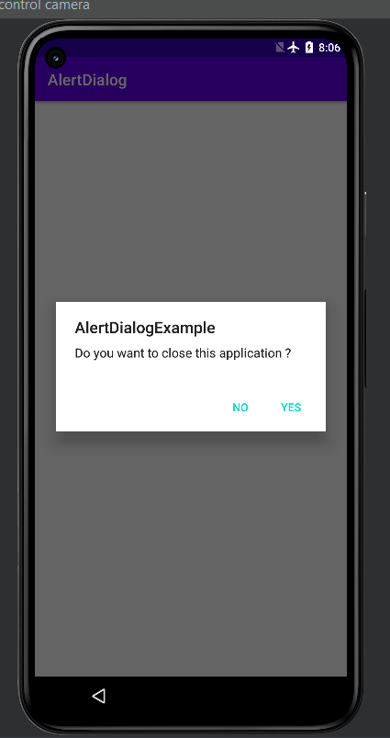**Output:-**

